Unit 7 – Activity 2 Designing the Website
You are working for your chosen client (for example, a small business, organisation, or community group). Your task is to design a website that meets the needs of both the client and their target users. You will create detailed design ideas and plan how your website will look and function before you build it in Activity 3.
This activity links to Learning Aim B and covers:
- B.P3 – Produce a basic design for a website.
- B.P4 – Outline client and user requirements.
- B.M2 – Produce a detailed website design that meets identified requirements.
- B.D2 – Produce a comprehensive design that clearly meets both user and client needs.

Step 1 – Understand the Client and User Requirements (B.P4)
Begin by describing who the website is for and what it needs to do. Include:
- The purpose of the site (e.g. to inform, promote, sell, or educate).
- The target audience (age, interests, access needs).
- What information or features the client wants (contact form, gallery, booking page, etc.).
- What users need (clear navigation, quick access, readable layout).
Tip: Write a short paragraph describing the client and another for the target users.

- Client Description:
The client is a local coffee shop that wants a website to promote their brand and make it easy for customers to order online for delivery or in-store pickup. The site should showcase the café’s menu, highlight best-sellers and suggested combos, display photos of the space and products, include a contact page, and even a hiring ad for new staff.
- Target Users:
The website is for existing clients and potential new customers, including students, workers, families, and tourists. Users need a site that is easy to navigate, with a clear layout and quick access to the menu, online ordering, opening hours, and contact information. Features like best-sellers, suggested combos, a gallery, booking or pre-order page, contact page, and hiring ad will help meet their needs.

Step 2 – Create a Site Map (B.P3)
Draw a diagram showing the structure of your website. Include:
- The home page and all sub-pages.
- How each page links together.
- Any external links (social media, other sites).
Tip: Use arrows to show links between pages and label each page clearly.

Website Diagram:
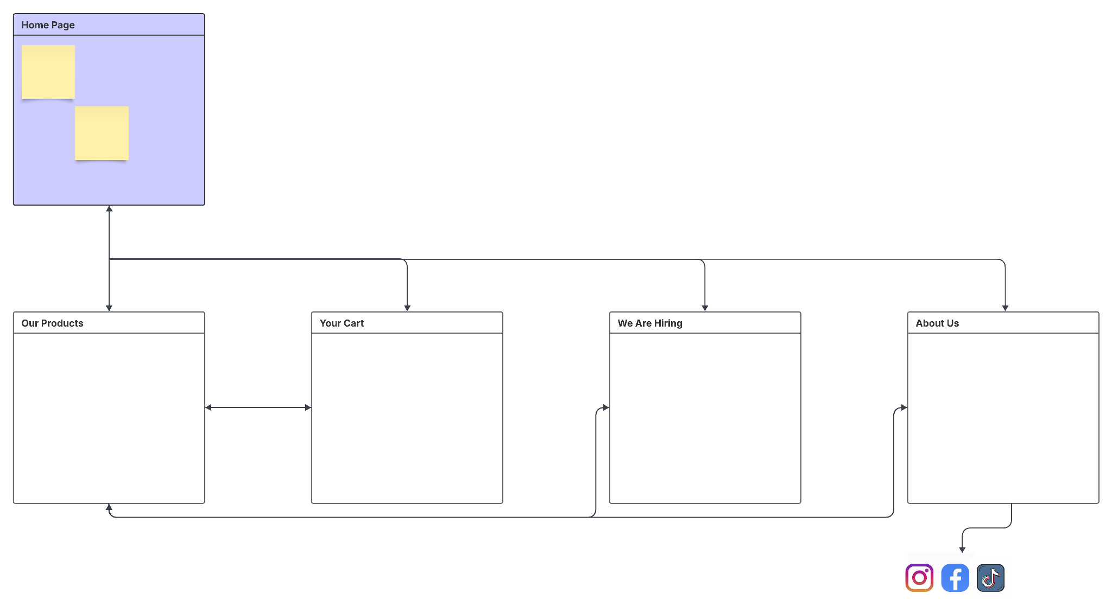

Step 3 – Design Your Page Layouts (B.P3 / B.M2)
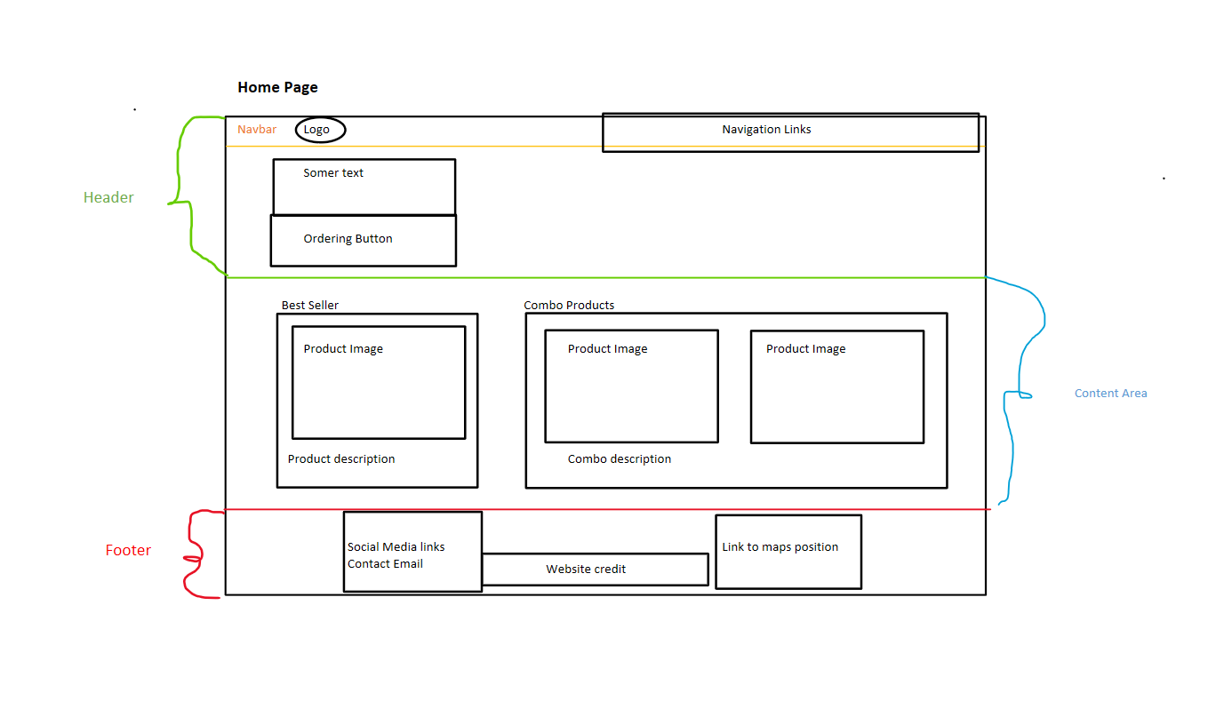
Create wireframes (page sketches or digital mock-ups) for each page. Each wireframe should include:
- Header, navigation bar, content area, and footer.
- Placement of text, images, videos, and buttons.
- Consistent structure across all pages.
Tip: You can draw them by hand (and scan) or create them digitally (Word, PowerPoint, Canva, Figma, etc.).

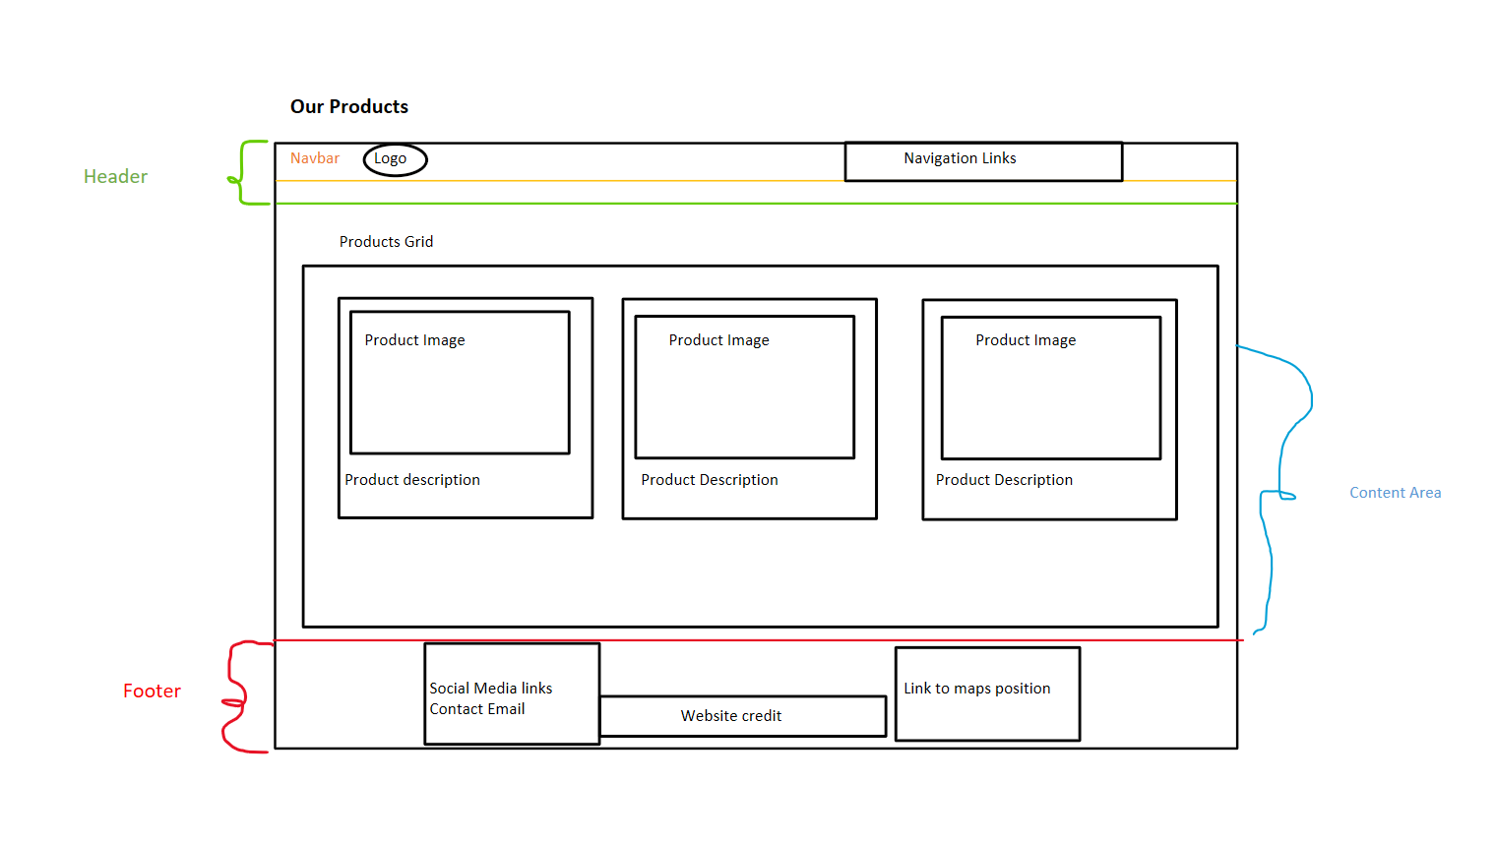

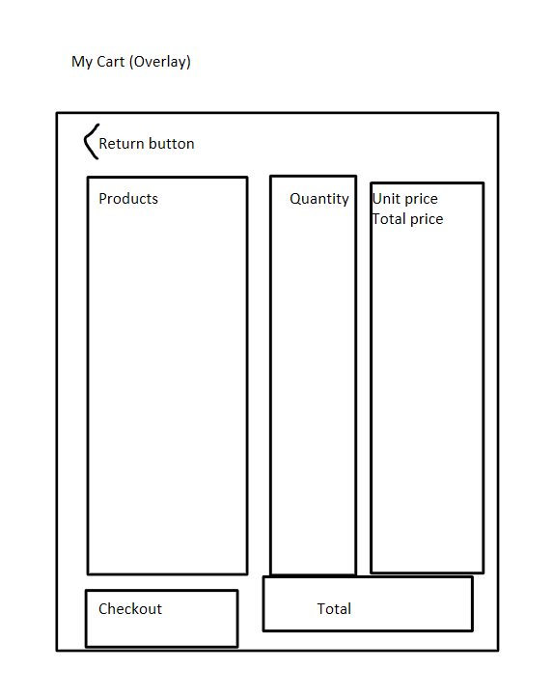

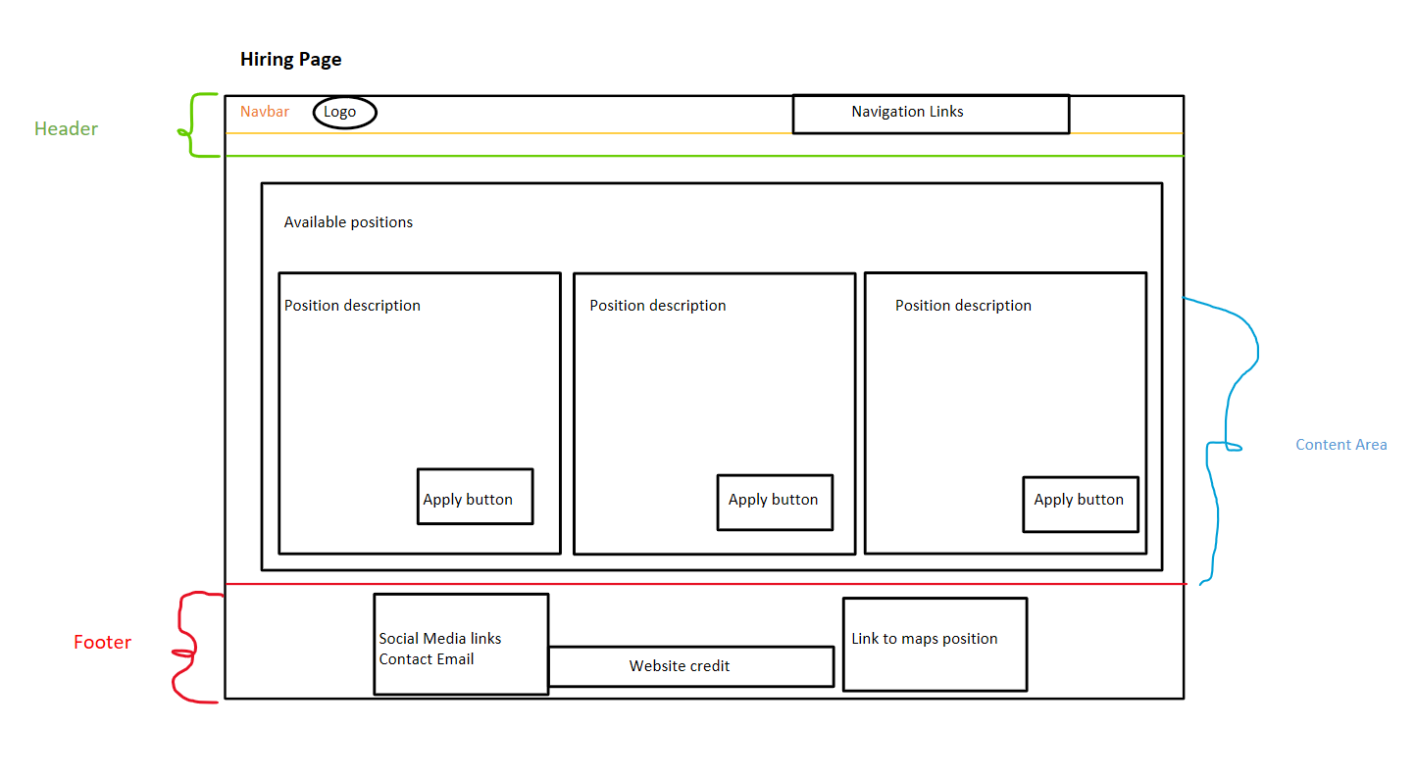

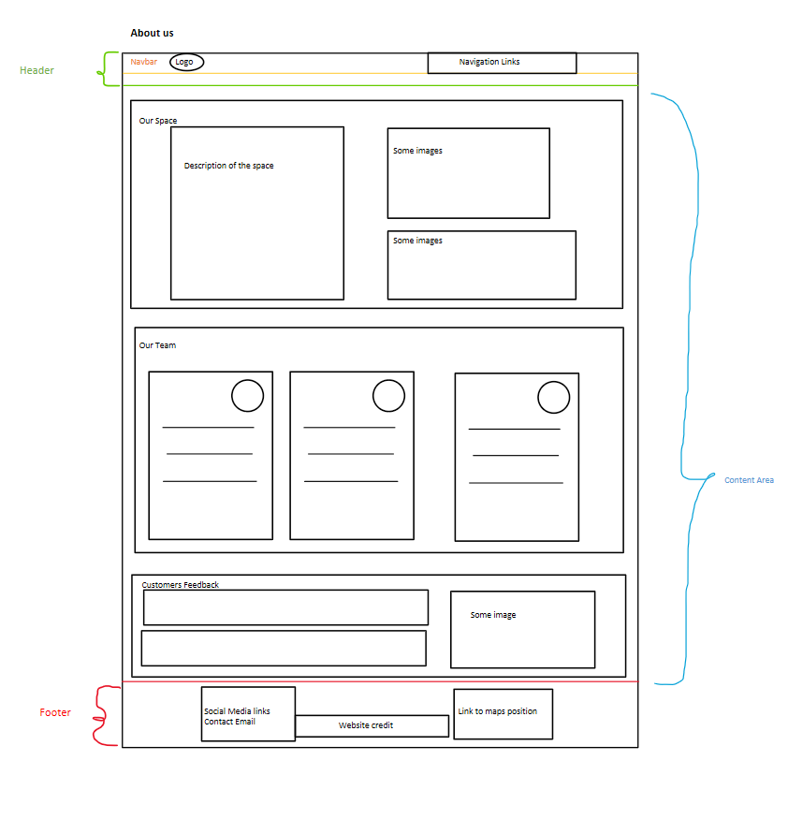

Step 4 – Decide on Style and Theme (B.M2 / B.D2)
Choose a consistent look and feel for the website. Include:
- Colour scheme – and explain why it suits the audience.
- Font styles and sizes – ensure readability and consistency.
- Images and graphics – relevant, clear, and suitable.
- Logo and branding – if applicable.
Tip: Explain how your design matches the client’s identity and audience preferences.
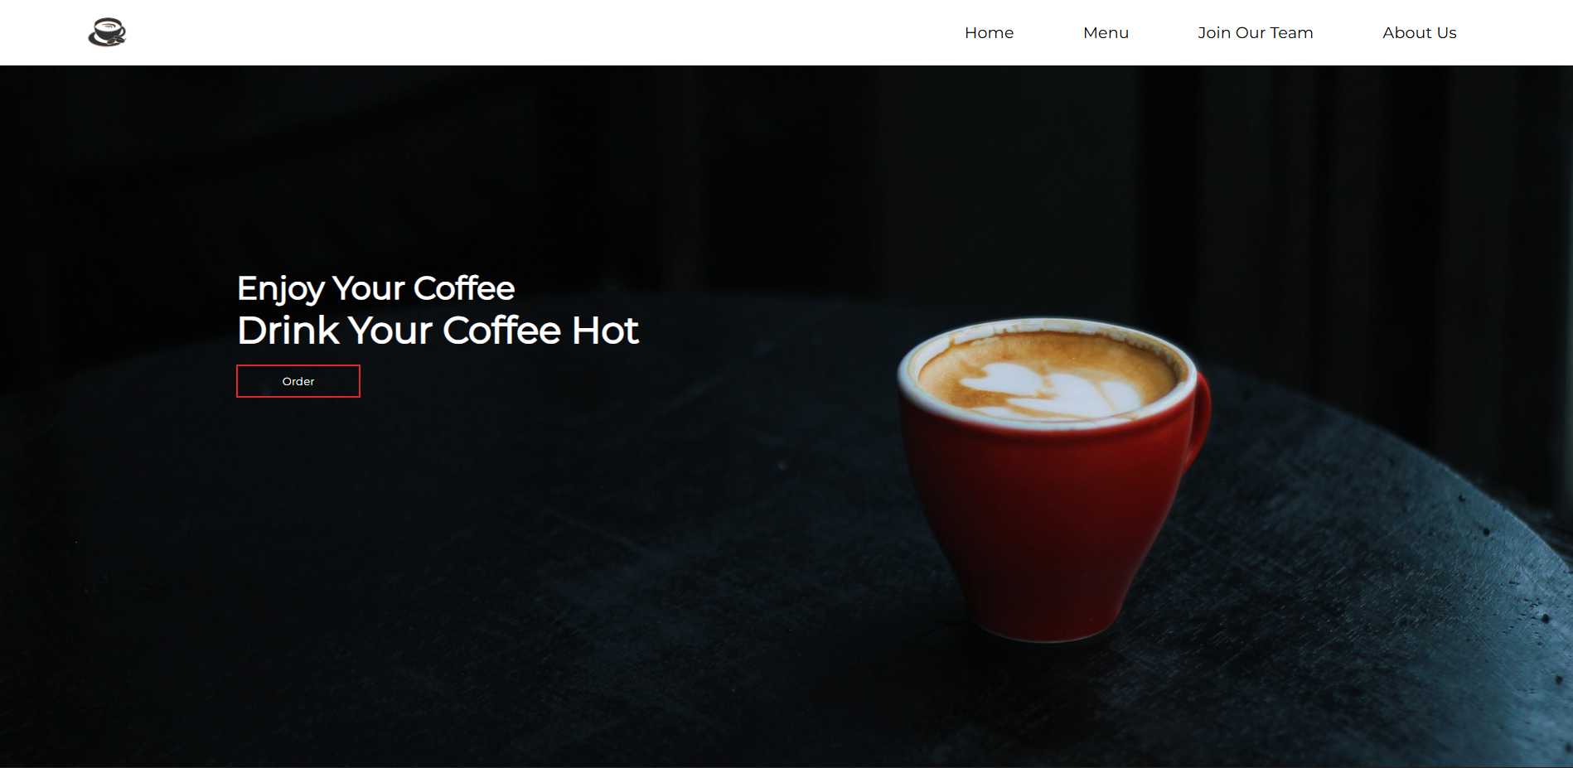
Page Example:

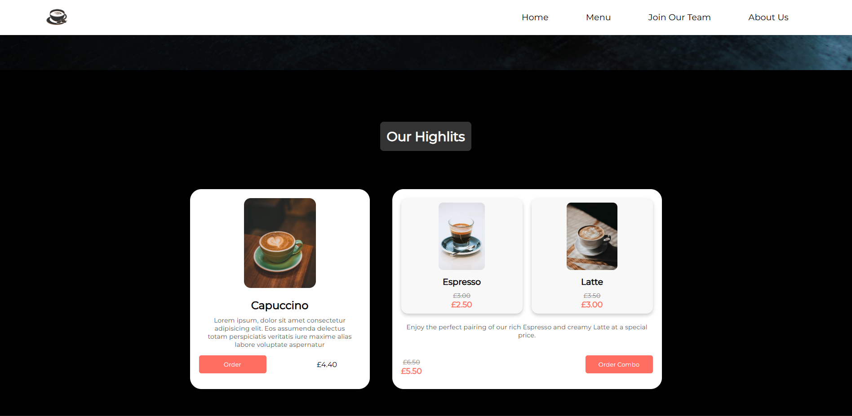

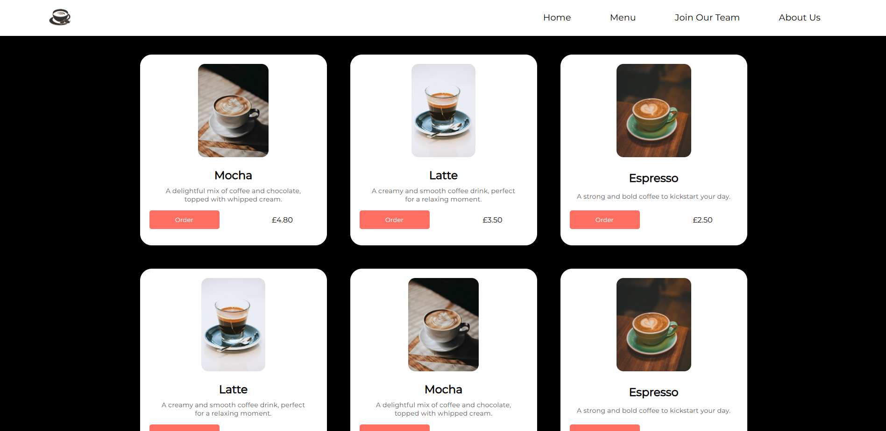

- Colour Scheme:
  - Primary Colours:
    - Dark Black / Charcoal (#1C1C1C): Background for a sophisticated, modern feel. Creates contrast to highlight coffee cups and text.
    - Rich Red (#D32F2F): Matches the red coffee cup in the hero image. Evokes warmth, energy, and appetite, which is perfect for a coffee brand.
    - Cream / Off-White (#F5F5DC): For text highlights or subtle accents; easy on the eyes and maintains readability against dark backgrounds.
Why it suits the audience: Coffee enthusiasts often appreciate cozy, warm, and inviting aesthetics. The dark background makes the product (coffee) pop, while the red accent gives a sense of energy and is great for drawing attention to CTAs (Calls to action) like “Order” or “Menu.”

- Font Styles and Sizes:
- Headings:
  - Font: Montserrat or Poppins (Sans-serif, modern and clean)
  - Weight: Bold for emphasis
  - Size:
- Hero Heading: 48–56px
- Section Headings: 32–36px

- Body Text:
  - Font: Roboto (Sans-serif, readable for longer text)
  - Weight: Regular
  - Size: 16–18px

- Buttons/CTAs:
  - Font: Same as headings for consistency
  - Weight: Medium and Bold
  - Size: 16–18px
Consistency: Using the same font family for all headings and one family for all body text. This creates visual hierarchy without clutter.
- Images and Graphics:
  - Hero Image: High-resolution image of coffee cup.
  - Content Images: Lifestyle images (people enjoying coffee, cozy interior shots) rather than generic stock photos.
  - Graphics / Icons: Simple line icons for menu, ordering, or social media links. More on the minimal side to match the modern aesthetic.
Why it works: Clean, high-quality images appeal to coffee lovers and give a sense of quality and comfort, aligning with a premium café brand.
- Logo and Branding:
  - Logo Idea: A minimalist coffee cup icon.
  - Placement: Top-left of the header, always visible on scroll for brand recognition.
Consistency: Use Hero page cup colour (red or black) in buttons, links, or hover effects to tie the brand identity together.

Step 5 – Consider Accessibility and Usability (B.M2 / B.D2)
Explain how your design will be accessible to all users. Examples:
- High-contrast colours for visibility.
- Large, readable fonts.
- Alt text for images.
- Simple, clear navigation.
- Consistent buttons and menus.
Tip: Show awareness of users with visual, motor, or cognitive difficulties.
- High-contrast colors:
  - The text “Enjoy Your Coffee / Drink Your Coffee Hot” is white on a dark background, which creates strong contrast and improves readability for users with low vision or colour blindness.
  - The red “Order” button on a dark background also stands out, making it easy to locate.
- Large, readable fonts
  - The headings use a large, clear sans-serif font that is easy to read. This benefits users with visual impairments or dyslexia.
  - Simple, uncluttered text avoids cognitive overload.
- Alt text for images: The coffee image should include descriptive alt text like “Red cup of latte on a dark table with milk art on top”. This helps screen reader users understand the visual content.
- Simple, clear navigation:
  - The navigation bar is straightforward with four clear links: Home, Menu, Join Our Team, About Us.
  - The menu items are logically grouped, which benefits all users, including those with cognitive difficulties.
- Consistent buttons and menus: The “Order” button is clearly defined and visually distinct. Consistent placement across pages ensures users know where to click.

Step 6 – Create a Testing Plan (B.M2 / B.D2)
Before building your website, plan how you’ll test it later. Include:
- What will be tested (links, images, layout, navigation, form submissions).
- How you will test it (self-check, peer test, feedback from users).
- What success will look like (pages load correctly, navigation works, text is readable).
What will be tested | How it will be tested | Expected result
Navigation links | Click each page link | All pages open correctly
Image display | View each image on different devices | Images appear correctly and load quickly
Tip: Create a small table like this to show your testing plan.
(MAKE YOUR OWN DO NOT USE THIS)
Test Plan:

What to Test | How to Test | What Success Looks Like
Links | Click on "Home", "Menu", "Join Our Team", "About Us", and the "Order" button. | Each link/button navigates to the correct page without errors.
Images | Check that the coffee image loads correctly and is displayed properly on different screen sizes. | The image is clear, loads quickly, and aligns well with the page layout.
Layout | View the page on desktop, tablet, and mobile. Check spacing, alignment, and responsiveness. | Page elements (text, images, buttons) are aligned and layout adjusts correctly for all screen sizes.
Navigation | Test the menu and header links, and the "Order" button. | Navigation is smooth, menu links are clickable, and users can move around the site easily.
Text Readability | Check the visibility of headings: "Enjoy Your Coffee" and "Drink Your Coffee Hot". | Text is clear, easy to read, and contrasts well with the background.
Form Submissions | Test forms linked from "Join Our Team" or "Order". Fill out and submit the form. | Form submits correctly, confirmation message appears, and no errors occur.

Step 7 – Justify Your Design Choices (B.D2)
Explain why you made your design decisions:
- Why did you choose those colours and fonts?
- Why that layout?
- How does your design meet the client’s goals and appeal to users?
- What makes it better than a basic design?
Tip: Use comparison words such as “This is more suitable because…” or “This layout improves user experience compared to…”

- Colours and Fonts:
  - Colours: I chose a dark background with a red coffee cup and white text. This is more suitable because the dark background makes the coffee cup stand out, attracting the user’s attention immediately. Red is warm and inviting, which fits the idea of hot coffee. White text contrasts well with the dark background, making it readable. Compared to a plain white background, this colour scheme is more visually striking and memorable.
  - The white text boxes: for products display provide clarity and readability against the black background. Users can quickly read the coffee descriptions without straining their eyes.
  - Brown coffee images: The rich, natural brown tones naturally draw attention and appeal to the senses, evoking warmth and freshness.
  - Fonts: I used a clean, sans-serif font (Montserat) for headings and body text. This is better than a decorative font because it is easy to read on all devices and creates a modern, professional look.

- Layout: The layout places the navigation bar at the top and a central hero image with text and a call-to-action (CTA) button. This layout improves user experience compared to a basic design because:
  - The navigation is immediately visible, making it easy for users to explore the site.
  - The hero section highlights the main message (“Enjoy Your Coffee / Drink Your Coffee Hot”) and the CTA button (“Order”), focusing users’ attention on the most important action.
  - The single, large coffee image makes the page visually appealing without clutter.
  - Grid layout for coffee items: Items are arranged in neat rows and columns, which improves user experience compared to a single long column. Users can quickly scan multiple items at once without excessive scrolling.

  - Each coffee card contains an image, a title, and a description: This hierarchy is clear: the image grabs attention, the name informs, and the description persuades.

- How the Design Meets Client Goals and Appeals to Users: The client likely wants to promote their coffee and encourage orders. This design supports that goal by using:
  - A visually appealing coffee image to entice customers.
  - A clear CTA button to drive orders.
  - The layout supports quick decisions: users can see multiple options at a glance and read descriptions if they want more detail.
  - Readable text to communicate the brand message immediately.
  - Users are attracted to the clean, modern look and easy navigation, which makes the website more engaging than a basic, text-heavy site.

- Why It’s Better Than a Basic Design: Compared to a basic design with plain text and minimal images, this design is:
  - Compared to a basic design with plain text and images scattered randomly:
    - Clarity: The grid and card design organize information neatly.
    - Visual appeal: Strong image focus attracts users emotionally.
    - Readability: Contrasting text and background prevent visual strain.
    - Consistency: Uniform card sizes and spacing create a professional, polished feel.
  - This design is more engaging and modern than a simple text list, increasing the likelihood users will explore more items and spend time on the site.

